Individual Pathways
Activity 2.1
Revising genetics doc-8464
- Label the following diagram using the words provided.
Adenine | Chromosome | Cytosine | DNA | Guanine
Nitrogenous bases | Nucleus | Phosphate | Sugar | Thymine

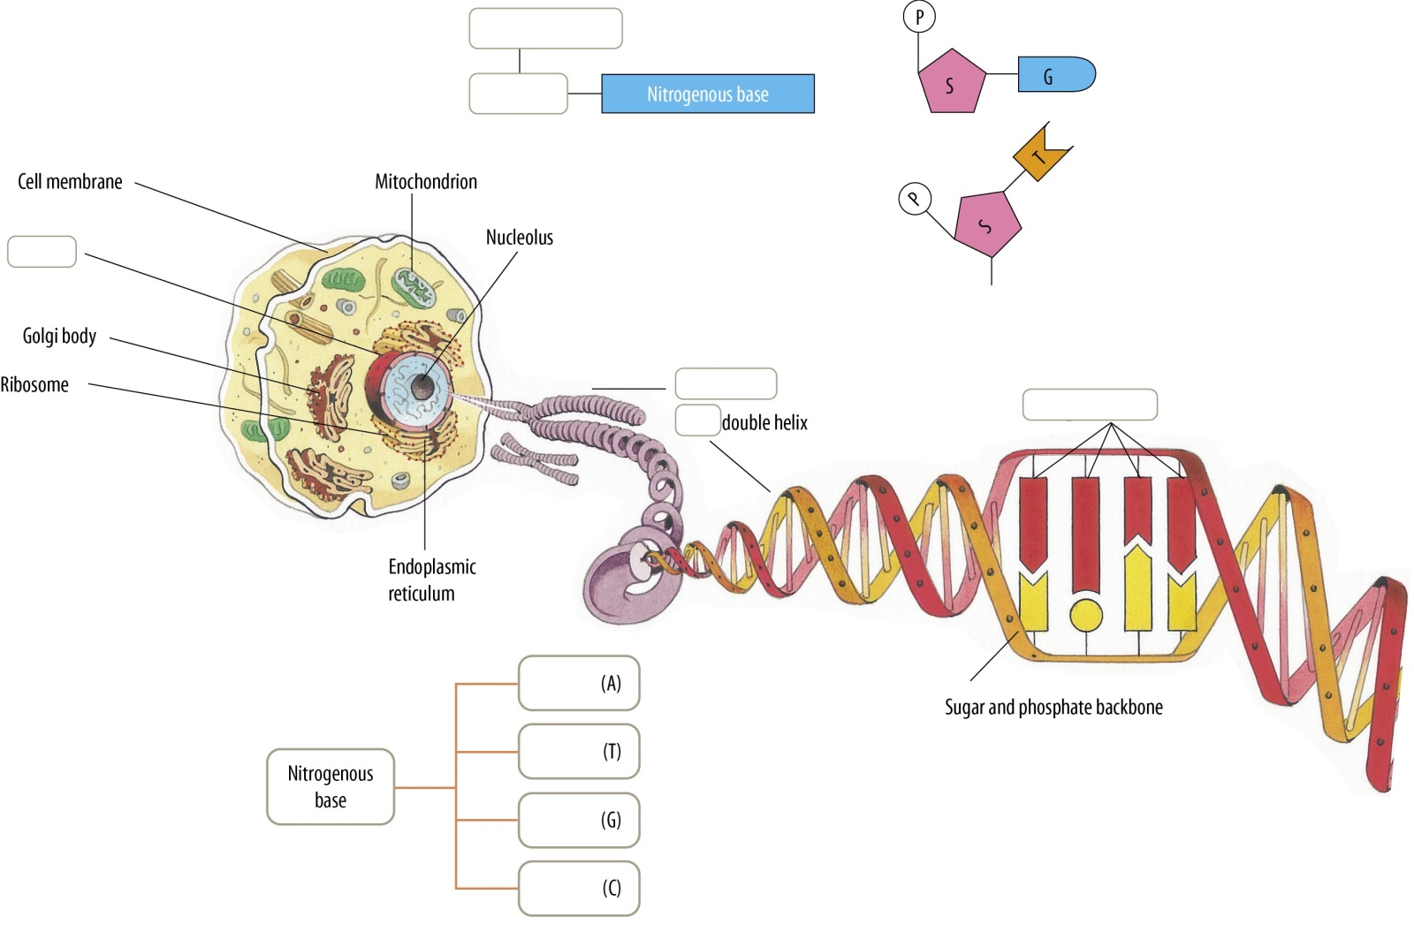

- Complete the following sentences about protein synthesis.
- The first step in protein synthesis is called ................................ It occurs in the ................................. of the cell.
- The second step in protein synthesis is called .................................. It occurs in the ................................. of the cell.
- Put the steps related to protein synthesis in the correct order.
 | ........... |  | A | tRNA in cytoplasm carries amino acids to ribosomes.
 | ........... |  | B | Copy of sequence is produced to form mRNA.
 | ........... |  | C | Amino acids are joined together at ribosome to make protein.
 | ........... |  | D | mRNA binds to ribosome.
 | ........... |  | E | mRNA passes through nuclear pores into cytoplasm.
 | ........... |  | F | DNA of gene is unzipped and DNA exposed.

- Complete the following sentences about mutations.
A mutation is a change in the DNA ............................ A ................................ mutation involves a large piece of DNA, while a ............................... mutation involves a single DNA base. There are three types of point mutations: ................................, (which involve the addition of single base), .................................. (which involve the removal of a single base) and ........................... (where one DNA base is replaced by another — for example, T replacing A, C or G). Mutations in .............................. cells are not passed onto the next generation. Mutations in sperm and ova that are passed on to the next generation are called ........................... mutations.
- Complete the transcription and translation activity below. Some information has been filled in for you.
Template strand of DNA
T | A | C |  | C | C | G |  | G | A | C |  | A | C | C |  | A | T | C
When this strand of DNA is transcribed, the resulting mRNA sequence is:
A | _ | G |  | _ | _ | C |  | C | _ | _ |  | _ | _ | _ |  | U | _ | G
When this mRNA sequence is translated, the resulting amino acid sequence is:
met |  |  |  | ____ |  |  |  | ____ |  |  |  | ____ |  |  |  | STOP

- Tommy, Chuckie, Susie and Angelica are childhood friends who are now adults. Tommy is married to Susie, and Chuckie is married to Angelica. Use the information below to determine the answers to each question about any children that these two couples may have.
- For each genotype below, indicate whether it is a heterozygous (He) or homozygous (Ho) genotype.
SS .......... Bb .......... NN .......... Ff .......... ss .......... nn ..........
Nn .......... ff .......... Ss .......... bb .......... BB.......... FF ..........
- Determine the phenotype for each genotype using the information provided.
- Straight hair is dominant to curly/wavy hair.
SS ...................................... Ss ...................................... ss ......................................
- Freckles are dominant to no freckles.
FF ...................................... Ff ...................................... ff ......................................
- For each phenotype, give the genotypes using the information provided.
- No glasses (N) is dominant to needs glasses (n).
No glasses = ........................................ Needs glasses = ........................................
- Blonde (B) is dominant to not blonde (b).
Blonde = ........................................ Not blonde = ........................................
- Tommy is heterozygous for straight hair while Susie is homozygous for curly hair.
- Complete the Punnett square below to show the possibilities that would result if Tommy and Susie had children.
 |  | Tommy
 |  | S | s
Susie | s
 | s

- List the possible genotypes and phenotypes for their children.
.....................................................................................................................................................
- What are the chances of a child with straight hair?
.....................................................................................................................................................
- What are the chances of a child with curly hair?
.....................................................................................................................................................

- Angelica does not need glasses, but she is heterozygous (Nn) for this trait. Her husband, Chuckie, needs glasses (nn).

- Draw a Punnett square below to show the possibilities that would result if Angelica and Chuckie had children.

- List the possible genotypes and phenotypes for their children.
.....................................................................................................................................................
- What are the chances of a child who needs glasses?
.....................................................................................................................................................
- What are the chances of a child who does not need glasses?
.....................................................................................................................................................

- Use the Pickle’s family pedigree below to answer the following question about the inheritance of ABO blood groups in this family.
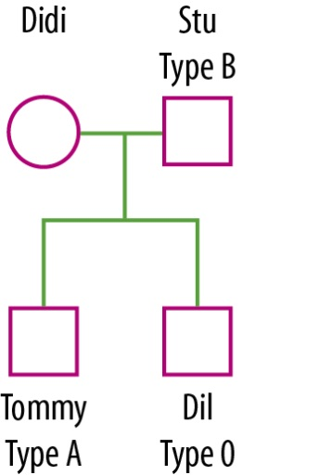
What is Didi’s blood type and genotype? Give a reason for your answer.
....................................................................................................................................................................................................................................................................................................................................
..................................................................................................................................................................

- Scott is a high school student who thinks he is a werewolf. Eventually Scott discovers that he was misdiagnosed and is not actually a werewolf, but suffers from hypertichosis (werewolf syndrome), an X-linked dominant disease. Scott knows his biological father also suffered from the disease, but he does not know if his biological mother was affected by it because she passed away soon after he was born.
- Referring to the pedigree chart below, explain why Scott had the disease but his brother did not.
....................................................................................................................................................................................................................................................................................................................................
..................................................................................................................................................................

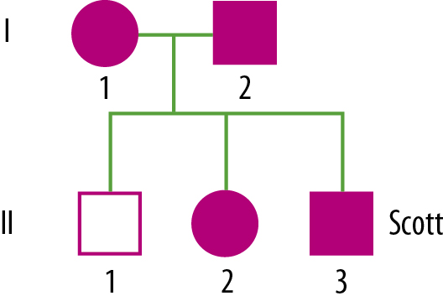

- Complete the following Punnett square; then explain why you would not expect all of Scott’s children to have the disease if he married a woman unaffected by the disease.
....................................................................................................................................................................................................................................................................................................................................
..................................................................................................................................................................

 |  | Scott
 |  | X^{W} | Y
Female partner | X^{w}
 | X^{w}

- The mnemonic ‘Indian People Make Artistic Teepees’ is used to help remember the stages of mitosis. The first letter of each word is the same as the first letter for a stage of mitosis, and the letters are in the correct order.
Fill in the names of the phases in the following table, and match the names to the descriptions of what happens at each stage.
 | I................ |  | .......... | A | This is the final stage of mitosis where tidying up happens — nuclear membranes reform and cytokinesis occurs, resulting in two identical daughter cells.
 | P................ |  | .......... | B | This is the stage of mitosis where chromosomes are invisible — we cannot see individual chromosomes while they are replicating.
 | M................ |  | .......... | C | This is the stage of mitosis where spindle fibres attach to the centromere and pull sister chromatids apart.
 | A................ |  | .......... | D | This is the stage of mitosis where chromosomes line up in homologous (matching) pairs.
 | T................ |  | .......... | E | This is the stage of mitosis where chromosomes move to the middle of the cell.

- Complete the following table comparing mitosis and meiosis in humans. Some information has been filled in for you.
 | Mitosis | Meiosis
No. of cell divisions |  | 2
No. of DNA replications |  | 1
No. of daughter cells produced | 2
No. of chromosomes in parent cell |  | 46
No. of chromosomes in daughter cells |  | 23
For growth and development? (Yes/No) |  | No
For reproduction? (Yes/No) | No

- What is genetic testing and why is it carried out?
....................................................................................................................................................................................................................................................................................................................................
- What are some of the problems that could arise as a result of genetic testing?
....................................................................................................................................................................................................................................................................................................................................
- Dolly the sheep was created by nuclear transfer cloning. Put the steps below in order to explain how Dolly was cloned.
 | ........... |  | A | A donor cell is taken from a sheep’s udder — this is the animal being cloned.
 | ........... |  | B | The embryo develops normally into a lamb — Dolly.
 | ........... |  | C | The two cells are fused using an electric shock.
 | ........... |  | D | An egg cell is taken from an adult sheep.
 | ........... |  | E | The embryo is placed in the uterus of a foster mother.
 | ........... |  | F | The fused cells begin dividing normally to become an embryo.
 | ........... |  | G | The nucleus of the egg cell is removed.

- Revise the key terms in this chapter by completing the following word search using the clues and words provided.
alleles | amino acids | autosome | carrier | centromere | chromatid
chromosome | clone | codominant | codon | crossing over | diploid
DNA | DNA fingerprinting | dominant | gene | genetic engineering | genome
genotype | haploid | heterozygote | homozygote | incomplete dominance | independent assortment
karyotype | locus | meiosis | mitosis | mutation | phenotype
proteins | Punnett | recessive | replication | reproductive | sex-linked
therapeutic | totipotent | trait | transcription | translation
Word search clues:
- D…... is the abbreviation for deoxyribonucleic acid, which carries the information that determines biological characteristics.
- T…… is the term used to describe a particular characteristic of an organism.
- A k………… is a picture created by staining, arranging and numbering chromosomes in pairs by size, centromere position and banding pattern.
- A thread-like linear strand of DNA and associated proteins that carries genes and is responsible for the transmission of hereditary information is known as a c……………...
- A c…………. is one of the two identical copies of DNA making up a duplicated chromosome, which are joined together at their centromeres for the process of cell division.
- The region on a chromosome that joins two sister chromatids is called a c………….
- A chromosome that does not carry information for sex-related characteristics is called an a…………….
- The region of DNA containing instructions for making a protein is known as a g……..
- Different forms of the same gene are known as a……….
- The location of a gene on a chromosome is referred to as a gene l……….
- The total set of genes within an individual or cell is called the g……….
- The combination of alleles that you have for a particular trait is known as your g………
- The observable or measurable characteristics of an individual that result from the interaction between genotype and the environment are known as the p…………..
- An individual with two different copies of an allele coding for a specific trait is said to be a h…………..
- An individual with two identical copies of an allele coding for a specific trait is said to be a h…………….
- A trait is referred to as being d………… if it is expressed when only one allele that codes for it is present. The allele coding for this trait is represented by a capital letter.
- A trait is referred to as being r………… if it is only expressed when two copies of the allele that codes for it are present. The allele coding for this trait is represented by a lower case letter.
- With c…………… phenotypes, the phenotypes of both homozygotes are expressed equally in the heterozygote.
- With i………….. d………….., the phenotype is only partially expressed in the heterozygote, so the heterozygote has a different phenotype from either homozygote.
- A c………. does not show the expression of one copy of a recessive gene. They may pass a disease onto their offspring but do not have the disease themselves.
- Conditions that are caused by genes on the X chromosome are said to be s......-l…..... They are denoted by a superscript letter on an X (e.g. X^{H}).
- A P………….. square is used to predict the outcomes of a cross. The top row has the possible genotypes of gametes from the one parent and, in the left column, the gametes from the other.
- DNA r…………… is the process by which genetic material is copied in order for cell division to occur.
- M………… is cell division that results in identical daughter cells with a diploid cell number and is required for growth.
- When cells of a species contain pairs of chromosomes they are said to be d……..... cells.
- Cell division that results in gametes with a haploid cell number is known as m……….
- When cells of a species have one copy of each chromosome they are said to be h……….
- The phrase i……………. a………….. refers to the fact that during meiosis different combinations of chromosomes may end up together in the gametes.
- The exchange of genetic information between chromosomes during meiosis is the result of c………… o……., and contributes to increased variation in offspring.
- A m………… is a change in the DNA sequence of an organism.
- A series of three bases that acts as an instruction to add a particular amino acid to a growing polypeptide chain is a c……….
- The building blocks of proteins are a………. a….....
- P………… are made up of long chains of amino acids and other substances to form complex three-dimensional structures that play a role in determining the phenotype of an organism.
- T…………… is the process controlled by enzymes in which a gene’s DNA is unwound and the strands separated, and another type of nucleic acid (RNA) is produced.
- The assembly of a polypeptide or protein chain from amino acids occurs as ribosomes ‘read’ RNA and is known as t……………
- The cutting, joining, copying and separating of DNA by scientists is referred to as g…………. e………………
- The technique used to analyse DNA fragments for the purpose of forensic studies or paternity tests is known as D….. f……………..
- A newly formed organism resulting from asexual reproduction that is genetically identical to the parent is referred to as a c……..
- R…………… cloning involves separating the cells of a developing embryo and implanting them into different hosts so that multiple genetically identical offspring are produced.
- T………… cloning is a form of somatic cell nuclear transfer aimed at the artificial production of organs or tissue types for ‘replacement parts’.
- T…………. stem cells are cells from which a whole organism may develop.

